**Water Currents and Flow Generators**

Last Updated

# High Level Player Experience

The creator establishes a volume of current affected water within a larger body of water; the strength, the direction, the width and length. Generators are added to the current to control strength and direction through tiles.

The player experiences the currents by placing creatures and objects in the water and watching them move. Players can control the current using the generators.

**Feature Priority: Core feature of Win8 Kodu**

* *Core Feature*: A major feature that could be listed on the back of the box. It interconnects with multiple core features and is a major part of the player experience.

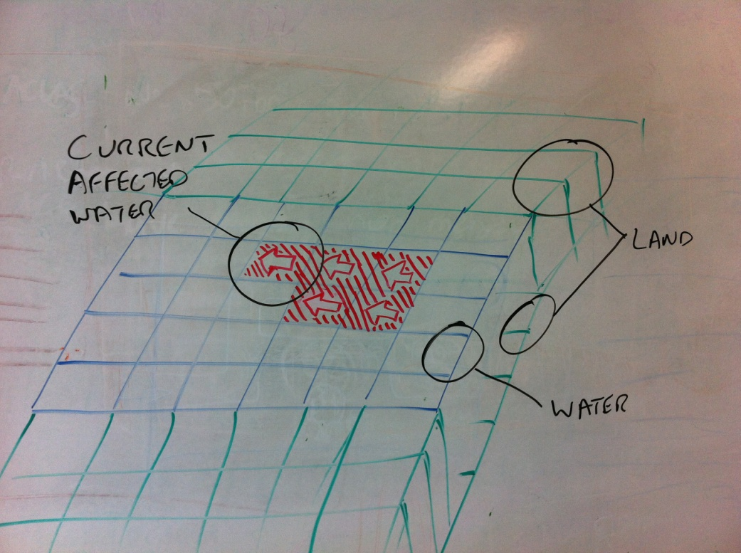

# Design Details

**Goals:**

* To get currents working
* To get generators to control currents

**Design Details:**

**Breakdown**:

* Currents
* Generators

**Currents** **Breakdown Details & Diagrams**

**Goal**:

* To push objects and creatures that are in the current in direction and speed of current.
* User defines dimension of current.
* Multiple currents are possible within 1 body of water
* Generators are not required

**Details**

To establish a current, there is a ‘current’ edit option (on the top level of the edit menu, to the right of add water).

Users paint the water just as they would texture terrain.

There are 8 current ‘terrains’, each one pointing in a different direction: North, North-East, East, South-East, etc.

Each current ‘terrain’ is semi transparent and red, with a white arrow indicating direction.

The current defaults to pushing at a medium speed rate.

Elsewhere there are 7 speeds of movement in Kodu; from slower to fastest. We will be mimicking this methodology and speed settings. I.e. Normal current speed pushes a character at the normal *on-land* pace.

See below on how to alter speed.

**Generators Breakdown Details & Diagrams**

**Goal**:

To give finer control of a current and to provide the player with capacity to alter a current to a different speed.

**Details**

The Generators are actually ‘modifiers’. They are placed in the world and via user programming, affect any current they are touching.

Generators only affect 1 current at a time. I.e. if one current heading west has the Generator placed on it and that western current flows contiguously into a northern current, the northern current is not affected by any changes the Generator makes to the western current.

Similar to characters, the player is able to alter:

* The speed
* If the current is going forwards or backwards.
* Unfrozen/Frozen (i.e. a toggle on/off)

Just as with characters, the speed is set by Do: Move/Rotate + (Add up to 3 speed tiles here)

* Slowly. Slowly. Slowly. – this setting provides minimal resistance.
* Slowly. Slowly.
* Slowly.
* Normal (default)
* Quickly. – this speed will push a character moving at normal speed backwards.
* Quickly. Quickly.
* Quickly. Quickly. Quickly.

Visuals

Generators have a visual component. This component is omni-directional like a buoy rather than having a bladed structure like a fan or turbine.

Settings

The player is able to set most settings similar to characters. I.e. Hit points, Ghost, Invisible and Mute.

Stretch goal:

Additionally, players are able to set a ‘Contiguous’ toggle. This is to let the players have the Generator effect only the part of the current it’s touching, or the whole current. I.e.

A) If the user has two currents next to each other but in opposite directions and wants to effect only 1 of them. (non-stretch implementation, detailed above)

B) Create an unbroken series of current ‘terrains’, such as a winding river and be able to reverse the whole thing at one Generator. (stretch goal aspect)

Default is Contiguous set to On.